Name: _________________________________

Confirmation Year 1
Nicene Creed + Lord’s Prayer

Special note: This lesson is intended as a review of the whole year, and as a chance to reflect on what you’ve learned and what you believe.

Part I: Nicene Creed

Instructions: Read the Nicene Creed here (http://www.usccb.org/beliefs-and-teachings/what-we-believe/). Watch the video here (https://youtu.be/0YNeTwWU1RE), and answer the following questions.

- What do you think it means to pray the Nicene Creed “like a robot?” (2-3 sentences)

- In your own words, what did Jesus do for our salvation? (Quotes at 47 seconds; 3-4 sentences)

- In 1-2 words, why did Jesus save us from our sins and give us new life?

- In 1-2 words, where does the Holy Spirit live?

- In your own words, define “Church.” (2-3 sentences)

Part IV Instructions: Fill out the visual organizer below. Think about the statements of the Creed that you can really say you believe in. It’s ok if you’re not 100% of the way there. Add anything else that you believe about God to the chart, even if it isn’t from the Creed.
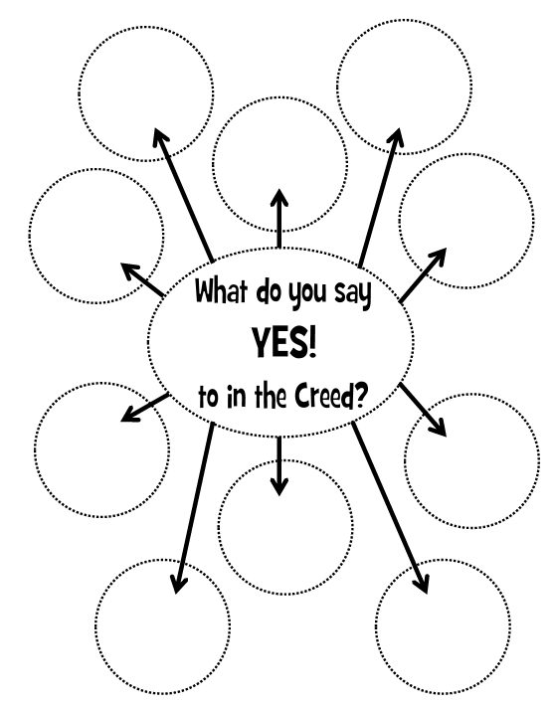
What do you believe about God?
Part II: The Lord’s Prayer
Instructions: Read Chapter 49 + Chapter 50 in your textbook, then answer the questions below.
- What did Jesus teach us about prayer when he gave us the Lord’s Prayer? (2-3 sentences)

- What does the Lord’s Prayer teach us about God? (2-3 sentences)

- What does the Lord’s Prayer teach us about the kind of people we should be? (2-3 sentences)

- After reading about the seven petitions of the Lord’s Prayer in Chapter 50, “translate” the Lord’s Prayer here. Re-write the whole prayer in simple language that would help a 7 year old understand it:

